
Project

TimeShare
by the MEAN_Team2

V 1.0


Cédric THEDREZ aka K4M1coder
&
Nada VUJANIC-MAQUIN aka sysn00ps

AFC RAM Software Developer training – Afpa Langueux from 21/12/15 to 04/03/16

INDEX

Training phase context.........................................................................................................page 1
Project description...............................................................................................................page 2
Global application requirements.........................................................................................page 3
Feasibility study....................................................................................................................page 4
Risk-Quality analysis............................................................................................................page 5
Juridical-Contracts...............................................................................................................page 6
General functional specifications......................................................................................page 7
UML modeling..........................................................................................................................page 8
IHM conception.......................................................................................................................page 9
Development...........................................................................................................................page 10
Data base – MongoDB...............................................................................................page 10
Server – NodeJS.......................................................................................................page 11
IHM – AngularJS......................................................................................................page 12
Integrated chat service..........................................................................................page 13
Software acceptance phase...............................................................................................page 14
Server..........................................................................................................................page 14
IHM..............................................................................................................................page 15
Integrated chat service..........................................................................................page 16
Unit testing............................................................................................................................page 17
Server.........................................................................................................................page 17
IHM.............................................................................................................................page 18
Integrated chat service..........................................................................................page 19

Training phase context

The conception and web development of this project is neccessary for AFC RAM Software Developer training at the AFPA centre of Langueux.

The training will last 10 weeks, whether 210 heures in total from 21/12/2015 to 24/12/2015 than from 04/01/2016 to 04/03/2016 at the AFPA centre of Langueux at the rhythm of 3 days par week.

The group counts the total of 9 people.

The first day of training, we had a collective brainstorming session where we found the idea for the project.

On the server side, our trainer has proposed two different types of technologies : PHP Silex and NodeJS. The choice of database and "frontend" technologies remain the same: MongoDB and AngularJS.

The final technology choice was entirely up to us which resulted in 5 people taking NodeJS and 4 people taking PHP Silex. For the project management simplicity, the group of 5 people was further divided in two.

The group members of PHP Silex team are Arnaud, Stephane, Emmanuel and Erwann.
The group members of the 1st NodeJS team are Caroline, Said and Anoine.
The group members of 2nd NodeJS team are Cédric and Nada.

During the training we must manage the project from A - Z, ie, preliminary project study (application requirements, feasibility studie, risk-quality analysis), implementation of the software architecture, design, full stack development, software acceptance phase, tests.
Project description

The heart of the "Timeshare" project is exchange of user time for different services like gardening, babysitting, ...

To get the services access, user must imperatively create his profile on the platform and complete it. The sum of "60 Minutes" is automatically credited for the creation of new account.

Once done, he can offer a services, consult services and request a services. The ability to respond to any offer is naturally included.

The user can also assess the quality of the provided services by a comment and / or note.

The user will have at his disposal the creation of lists such as "Favorites" and the "Blacklist".

In case when user doesn't have the possibility to offer any service, he can try to find someone who will give him a "time gift". If not, he can not use the platform.

The chat service will be available to ease the communication process between users.

The geographic scope of the search ads is limited to the user home region area. Like that we can be sure that exchange of time for the services can happen in a reasonable time.

Global application requirements

Concerned area - Free services exchange between users from a network community.
Context description - The current service on the market, made by our competitors, lack of quality by the deficiency of offered services and the heaviness of their platforms.
Requirements description - Improved HTTP time request / response service (the establishment of a application workflow needs and the use of the database) and increased quality of the digital services (user experience, security, completeness).
Main advantages and challenges - Mastership of the rights assigned to the users, improved efficiency and safety of the clearance process, reactiveness and fluidity of the user interface.
Main risks linked to the use of the platform - Hijack of the service, malevolence and errors produced from the lack of the users rights control.
Main risks linked to development of the project - Bad definition of the "global application requirements" scope , no commitment to the deadlines, poor architectural choice will lead to the saturation of the platform.
Necessary project resources – 4 people * 21h/week during 10 weeks gives a total of 40 Days/Person.
Assigned project resources – 2 people * 21/h semaine during 10 weeks gives a total of 20 Days/Person.
Recalibration of the perimeter – The available resources given to the project are not sufficient to carry it out as a whole. Initially we have to prioritize. Only essential functionalities will be available at first so we can deliver the platform within the imposed deadline. The rest of functionalities will be added later, once the product is on the market.
Comments - There are no investment costs for the proposed solution nor the salary expenses because the project is built as a part of the school training program and will not be deployed on public networks.

Feasibility study

After a study of the competitors platform, we conclude that the project is entirely feasible, even encouraged.

Risk-Quality analysis

There is no risk because it's a school project (the production stage for the project is not expected). We will give our best to ensure the overall quality of application.

Juridical-Contracts

There will be no legal or contractual obligation for the project because it will not be deployed on the public network.

General functional specifications

Following of the 'user stories' from KANBAN board ( méthodologie SCRUM ) :
- As a non-connected user I want to know if there is a service near a chosen location with the number of service offering. If number of offers smaller than 5 we expand the geographical area
- As a non-connected user I can see the information on how the site works
- As a non-connected user I can see the stats ( proposals / requests )
- As a non-connected user I want to be able to "register" so I can take advantage of community services and fill my profile
- As a service provider ( connected user ) I have to validate the time taken for the finished task and I can note the friendliness and sincerity of the offer applicant
- As a registered user I want to connect through my social network account (Facebook, Twitter, G +, LinkedIN) or manually
- As a connected user I want to transfer (give) the time -> time gift
- As a connected user I want to know the remaining amount of time I have on my account -> time counter
- As a connected user I want to be able to delete my account
- As applicant ( connected user ) I have to evaluate -> note the quality of the service and can add a review. I also have to quantify the time being necessary for the termination of the service.
- As a connected user I control sharing on social networks
- As a connected user I want to know the identity of the person who provides the service
- As a connected user I want to be able to offer a service
- As a connected user I want to be able to filter the search by criteria (time, length of service, schedule, type of service, location, assessment of critaires)
- As a connected user I want to have a system of favorites and blacklist
- As a connected user I want to be able to ask directly a service from another user
- As a service provider ( connected user ) I can manage my availability
- As a connected user I can edit my profile and review the one of others (statistics, skills, assessments ...)
- As a connected user I can consult the offers and demandes
- As a connected user I want to recover my account if I loose the password

UML modeling
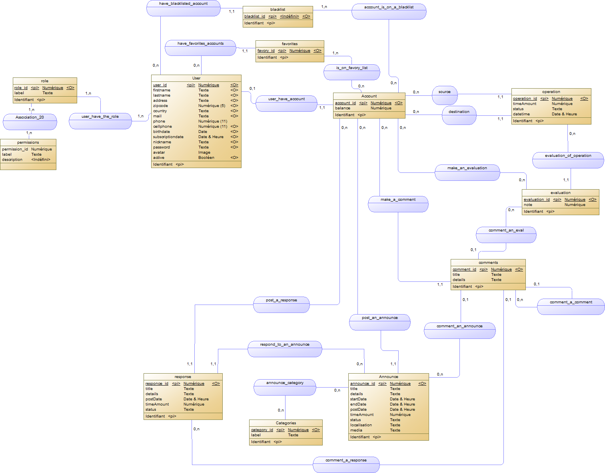

IHM conception

Home page

